**Title : Report on the Effect of Environmental Pollution on the Mysore Palace**

**1.Introduction**

Environment pollution refers to the contamination of natural resources like air, water, and soil, resulting from human activities. This contamination disrupts ecosystems, harms wildlife, and poses significant health risks to humans. There are various forms of pollution, including air pollution, water pollution, soil pollution, and noise pollution.

Air pollution is primarily caused by the emission of harmful gases and particulate matter from vehicles, industries, and burning of fossil fuels. This can lead to respiratory diseases, global warming, and acid rain. Water pollution occurs when harmful substances like chemicals, plastics, and untreated sewage are released into rivers, lakes, and oceans, endangering aquatic life and making water unsafe for consumption. Soil pollution results from the excessive use of pesticides, fertilizers, and improper waste disposal, leading to loss of soil fertility and ecosystem imbalance. Noise pollution, though less visible, affects both mental and physical health, leading to stress, hearing problems, and disturbance of wildlife habitats.

The consequences of environmental pollution are severe, including climate change, biodiversity loss, and health issues for living organisms. Addressing this issue requires collective efforts like adopting sustainable practices, stricter regulations, and public awareness campaigns to minimize harmful impacts on the environment.

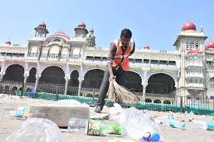

**2. Effect of Pollution on the Mysore Palace**

Pollution can have detrimental effects on historical monuments like the Mysore Palace, one of India's most iconic heritage sites. The primary concerns are air pollution, water pollution, and human-induced damage, which can lead to the gradual deterioration of its structure and aesthetic appeal.

1. Air Pollution : Emissions from vehicles, industries, and other sources in the vicinity of Mysore Palace can contribute to the accumulation of harmful pollutants like sulfur dioxide and nitrogen oxides. These pollutants, when combined with moisture, can lead to acid rain, which erodes the intricate carvings, walls, and domes of the palace. Additionally, dust and soot particles from pollution can settle on the palace’s surfaces, darkening its appearance and damaging the limestone and sandstone used in its construction.

2.Water Pollution: Any nearby sources of water contamination could indirectly affect the palace, especially if polluted water is used for cleaning or maintenance. Harmful chemicals in the water can lead to stains and damage to the structure over time.

3.Tourism Impact: With heavy foot traffic and improper waste disposal around the palace, environmental pollution from littering and increased vehicular emissions can accelerate wear and tear, making maintenance more challenging and costly. Preservation of Mysore Palace requires regular cleaning, reduced pollution levels, and sustainable tourism practices to maintain its cultural and historical significance.

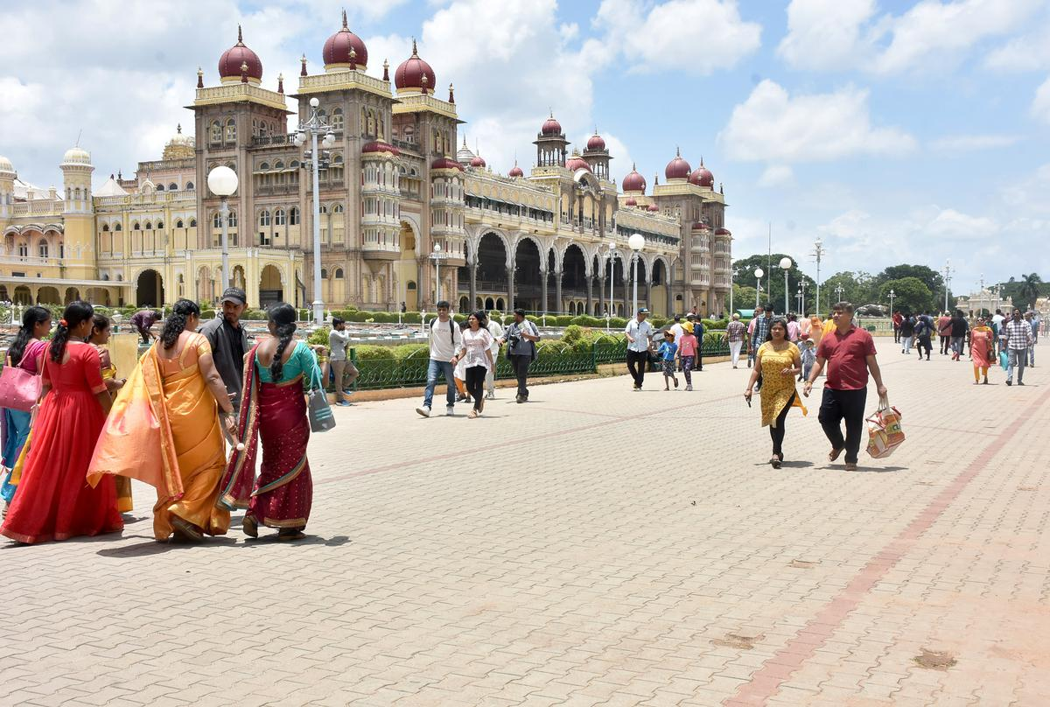

**3. Effect of Environmental Pollution on Plants and Non-living Things**

3.1 Impact on Plants Air pollution, particularly ozone (O3), sulfur dioxide (SO2), and nitrogen oxides (NOx), negatively affects plant life. Pollutants damage the leaf structure, inhibit photosynthesis, and stunt growth. Acid rain leaches essential nutrients from the soil, leading to poor plant health. In urban areas near monuments, trees and green spaces suffer from these conditions, impacting the aesthetic and ecological balance around historical structures.

3.2 Impact on Non-living Objects Non-living objects, especially those made of stone, metal, or cement, are particularly vulnerable to pollution. Acid rain, as mentioned earlier, reacts with minerals in the stone, leading to structural weakness. Metals corrode due to the combination of moisture and pollutants like sulfur and nitrogen compounds, creating rust and reducing durability. Cement structures, such as modern buildings and some parts of old monuments, also deteriorate when exposed to pollutants over time.

**4. Sources of Pollution**

Mysore Palace, one of India's most iconic landmarks, is subjected to various sources of pollution, which can affect its structure and surrounding environment. The primary sources of pollution in the area include:

1. Air Pollution:

- Vehicular emissions from the heavy tourist traffic around the palace.

- Industrial emissions from nearby factories, though Mysore is relatively less industrialized compared to larger cities.

- Dust and particulate matter from construction or roadworks in the vicinity.

2. Noise Pollution:

- Tourist buses and the general influx of visitors create noise, especially during peak tourist seasons or special events at the palace.

- Traffic congestion around the palace area also contributes to noise levels.

3. Waste Management Issues:

- Littering by visitors, especially plastic waste, can be a concern during large public events like Dasara celebrations.

- Improper disposal of waste in nearby markets or food stalls catering to tourists can contribute to the pollution.

4. Light Pollution:

- The Mysore Palace is beautifully illuminated at night, which is a major attraction, but excessive lighting can contribute to light pollution, impacting nearby ecosystems.

5. Water Pollution:

- Runoff from tourist areas and nearby marketplaces can carry pollutants into water bodies around the palace, although Mysore doesn't face severe water pollution issues directly at the palace itself.

These factors combined contribute to the overall pollution challenges faced by the Mysore Palace. Conservation efforts are continuously needed to preserve its cultural and architectural significance.



**5. Measures to Protect Monuments from Environmental Pollution**

In order to protect monuments like the Mysore Palace and others from the damaging effects of environmental pollution, several measures can be implemented. These include:

5.1 Air Pollution Control Reducing air pollution is essential for protecting historical monuments. Government policies and regulations should focus on limiting industrial emissions, vehicular traffic near heritage sites, and promoting the use of cleaner energy sources. Factories and industries should be required to install air filters and scrubbers to minimize the release of harmful pollutants into the atmosphere.

5.2 Regular Cleaning and Maintenance Regular cleaning and restoration of monuments can help prevent long-term damage caused by dust, grime, and pollutants. Non-corrosive and eco-friendly cleaning agents should be used to ensure that the materials used in the monument’s construction are not further degraded.

5.3 Use of Protective Coatings Protective coatings can be applied to monument surfaces to prevent the harmful effects of acid rain and particulate matter. These coatings, which are usually water-repellent and UVresistant, can help shield the structure from corrosion and environmental wear..

5.4 Public Awareness and Involvement Public awareness campaigns can encourage visitors and local communities to reduce pollution near heritage sites. Organizing clean-up drives, promoting sustainable tourism, and educating the public on the importance of preserving cultural heritage can foster a collective effort to protect these monuments.

5.5 Monitoring and Research Regular monitoring of pollution levels around monuments is necessary to assess the effectiveness of protective measures. Research into new methods of conservation and pollution control can provide innovative solutions to safeguard cultural heritage sites for future generations.

**Conclusion** :

Environmental pollution poses a significant threat to India's cultural heritage, with both famous and infamous monuments like the Mysore Palace suffering from its effects. While preventive measures such as pollution control and regular maintenance are being implemented at various sites, continuous effort is needed to preserve these monuments for future generations. The damage to plant life and non-living objects around these historical landmarks further highlights the far-reaching impact of pollution, urging the need for sustainable solutions to protect both the environment and cultural heritage.

